

MiniProject Report
on

Introducing CyberGuardian: Your Ultimate Cyber Security Guide
Submitted by

Project Members

Avishkar pokale -1032210798
Saurabh Jadhav-1032210970
Jaydeep Jadhav-1032210459
Vedang khare-1032210820

Department of Computer Engineering and Technology
MIT World Peace University, Kothrud,Pune 411038Maharashtra- India
2022-2023
Introduction

The increasing reliance on digital platforms for various aspects of our lives necessitates a robust cybersecurity solution. The project, titled "CyberGuardian" addresses this need by providing a comprehensive suite of cybersecurity tools and informative blogs. The goal is to create an environment where users can navigate the online landscape with enhanced safety and security guidelines on this platform

Features include:

- Cybersecurity Tools
- Cyberbot
- Cyber security Blogs
- Best Practices for Online Privacy
- User-friendliness

Features:

a.Cybersecurity Tools:

Password Strength Checker:

Functionality: Evaluates the strength of user passwords.
Importance: Strengthens one of the first lines of defense against unauthorized access.

Caesar Cipher Tool:

Functionality: Encrypts and decrypts messages using the Caesar cipher.
Importance: Offers a tool for secure communication through encryption techniques.
Email Header Analyzer Tool:

Functionality: Analyzes email headers for potential security threats.
Importance: Aids in identifying and mitigating email-based security risks.

Steganography Tool:

Functionality: Allows users to hide sensitive information within other files.
Importance: Provides a covert means of protecting information.

b. Cyberbot:
Objective: Engage users in meaningful conversations and provide assistance in the cybersecurity domain.
Technologies: Natural Language Processing (NLP) and machine learning.
Importance: Enhances user interaction by offering a conversational interface for cybersecurity queries and guidance.

c. Cybersecurity Blogs:

Content: Includes "Best Practices for Online Privacy" and other informative articles.
Objective: Educate users on cybersecurity best practices and create awareness.
Importance: Empowers users with knowledge to make informed decisions about their online activities.

Workflow
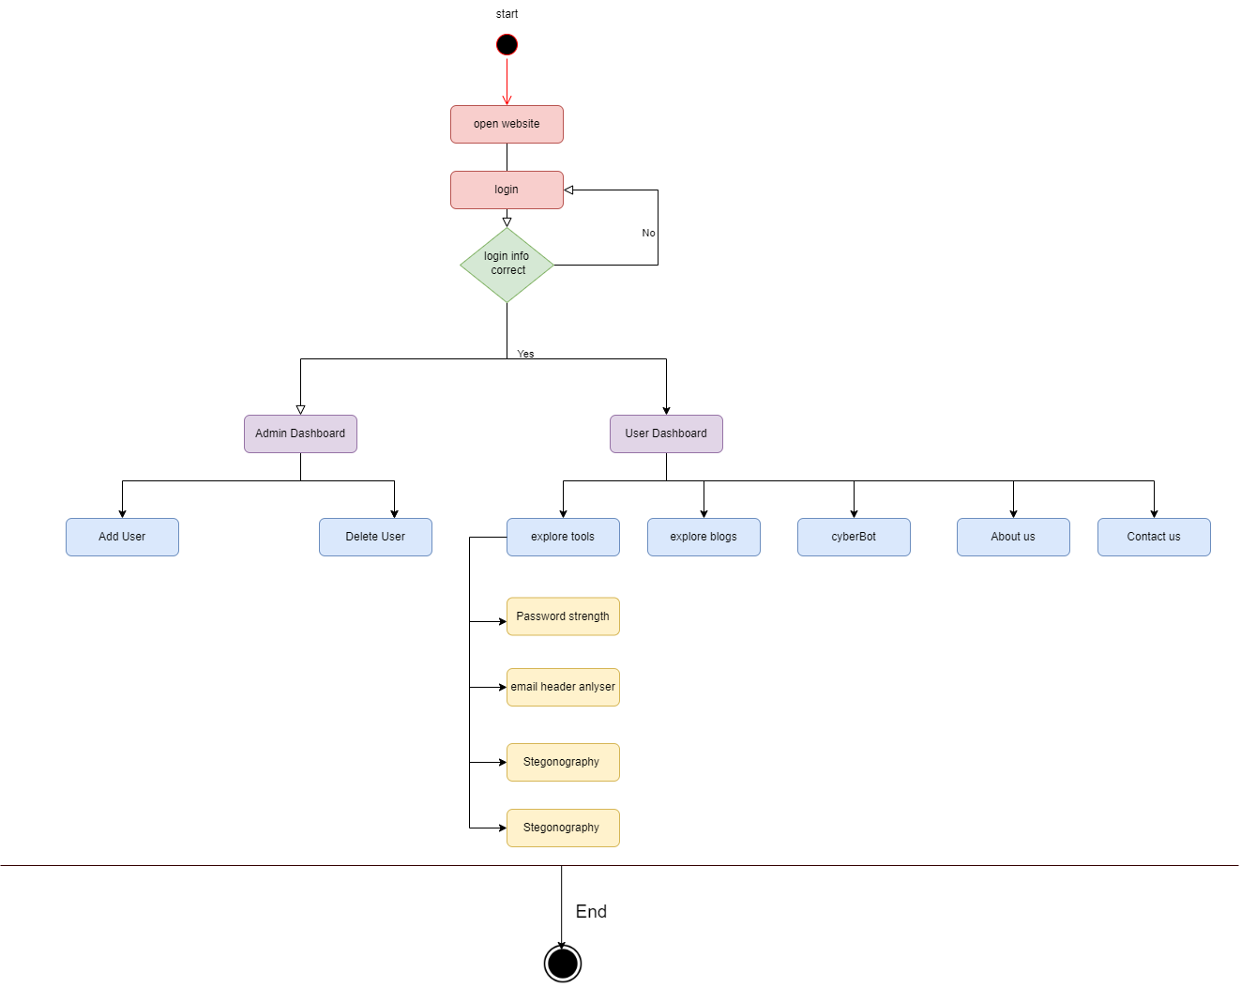

Overview Images

login Account Page
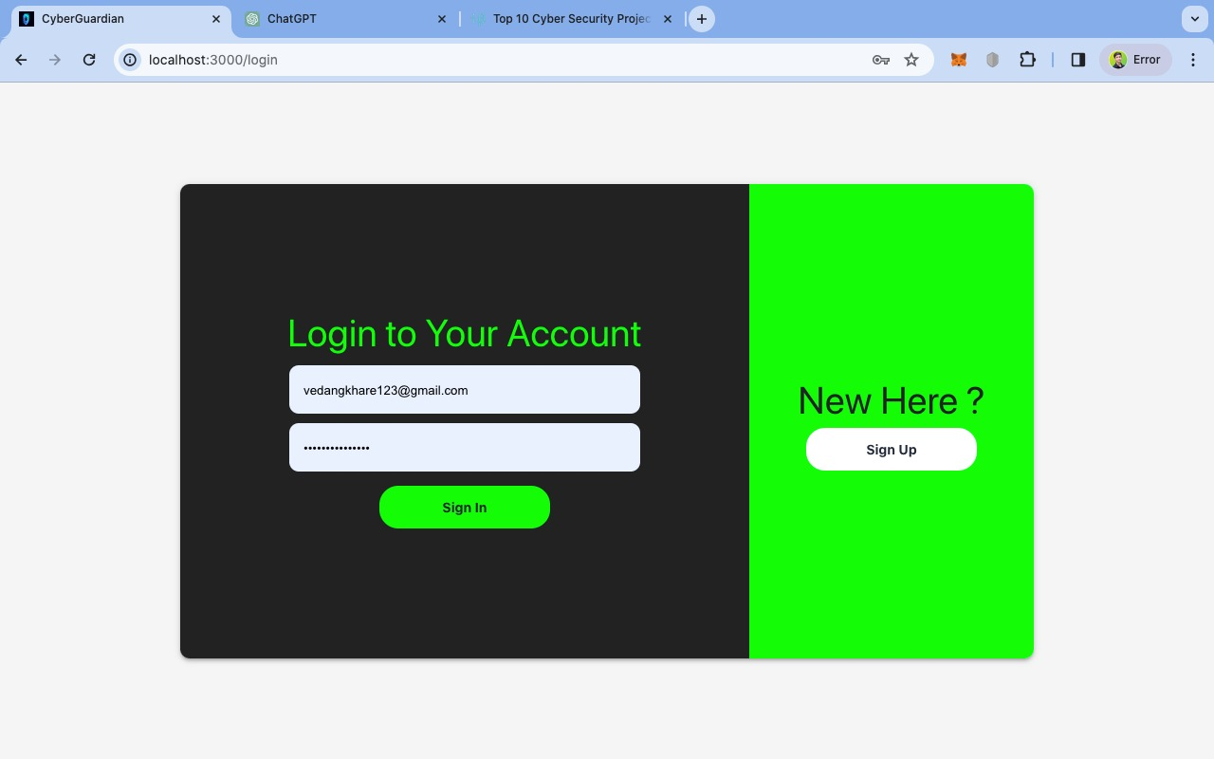

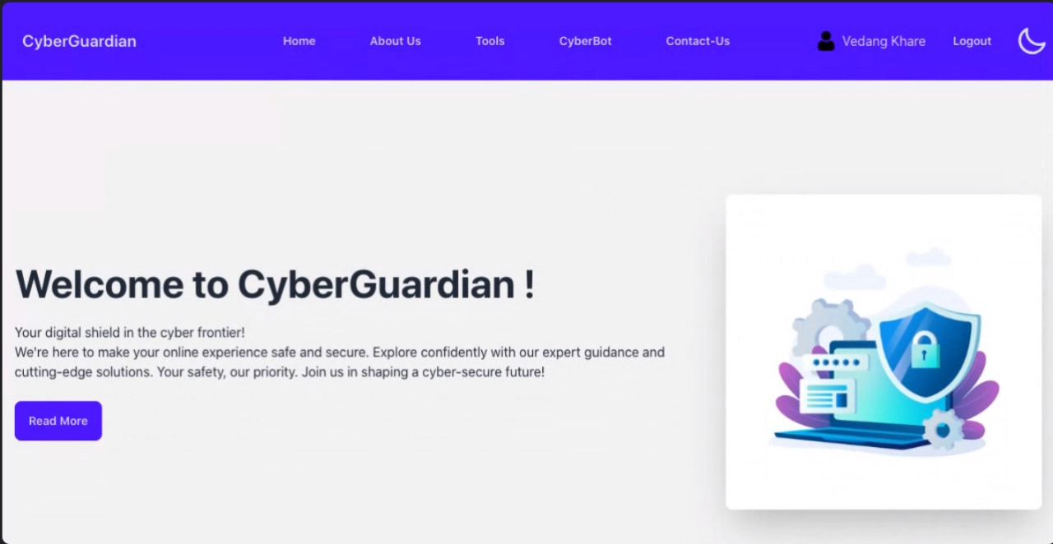
Dashboars

Tools

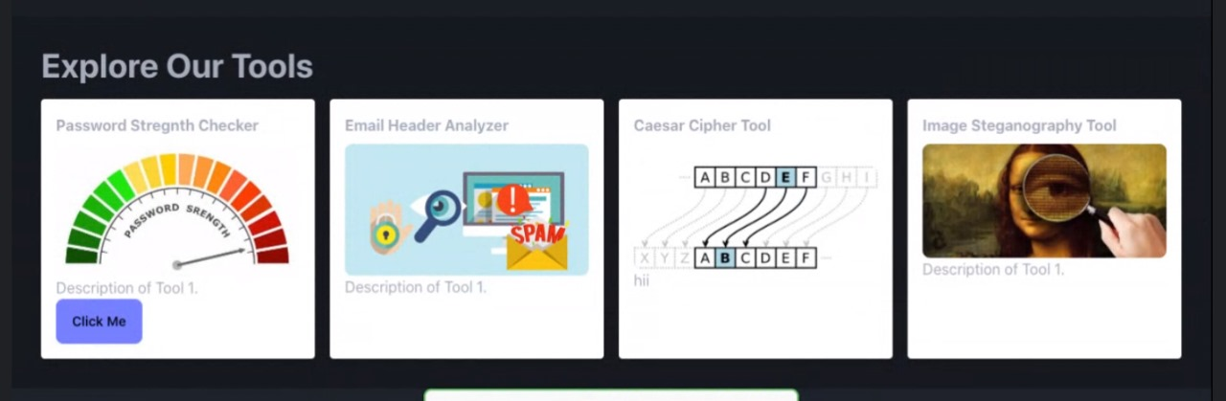

Benefits of CyberGuardian

Comprehensive Protection
Experience peace of mind knowing that CyberGuardian provides a holistic approach to online security guideline.

User-Friendly Interface
Navigate the app effortlessly and access its powerful features with our intuitive and user-friendly interface.

Regular Updates
Stay ahead of emerging threats with regular updates and enhancements to keep your digital environment secure.
Use of Fsd

CyberGuardian, which includes features like CyberBot, cybersecurity tools, and blogs, typically involves full-stack development. Full-stack development refers to the utilization of both frontend and backend technologies to build a complete web or mobile application. Here's a breakdown of how full-stack development can be used for your CyberGuardian app

- Frontend Development:
  - User Interface (UI): Frontend developers use technologies like HTML, CSS, React and JavaScript to create the visual components of your app. This includes designing the user interface for CyberBot, cybersecurity tools, and the blog section, ensuring a user-friendly and responsive experience.

  - Interactivity: Frontend developers implement interactive elements using frameworks like React, Angular, or Vue.js. This allows users to seamlessly navigate and engage with the app's features.
Backend Development:
  - Server-side Logic: Backend developers work on the server-side of the application using languages such as Python, Node.js, or Ruby. They handle data processing, user authentication, and interactions with databases.

  - Database Management: Full-stack development involves integrating a database (e.g., MySQL, MongoDB) to store information related to user accounts, cybersecurity tools data, and blog content.

  - APIs: Application Programming Interfaces (APIs) are developed to facilitate communication between the frontend and backend. For instance, the CyberBot feature may require real-time updates, and APIs enable data exchange between the server and the user interface.

Blog Section:
The blog section involves creating a content management system (CMS) on the backend to manage and publish blog articles. Full-stack developers design the frontend to display blog content dynamically, enabling users to access the latest cybersecurity insights.

Future Scope:

The future of CyberGuardian involves continuous improvement and adaptation to emerging cybersecurity challenges. Potential developments include:

Integration of advanced machine learning algorithms for real-time threat detection.
Expansion of the cybersecurity tools suite to address evolving threats.
Addition of more informative blogs to cover a broader range of online security challenges.

Conclusion:

CyberGuardian, with its multifaceted approach, emerges as a pioneering solution in the realm of online security. By offering not just tools but also educational content and a user-friendly interface, it is well-positioned to make a lasting impact. The commitment to ongoing development ensures that CyberGuardian remains relevant and effective in the face of ever-evolving cybersecurity threats, making it an invaluable asset for users seeking a secure and enhanced online journey.

